

2011 Canadian Masters Invitational
in conjunction with the
Irene MacDonald Memorial Competition

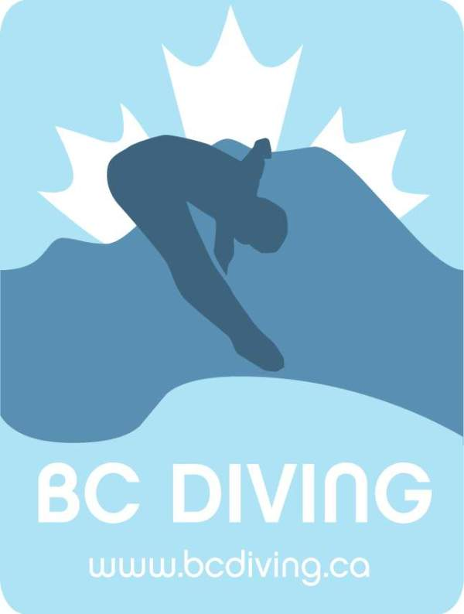

June 10-12, 2011

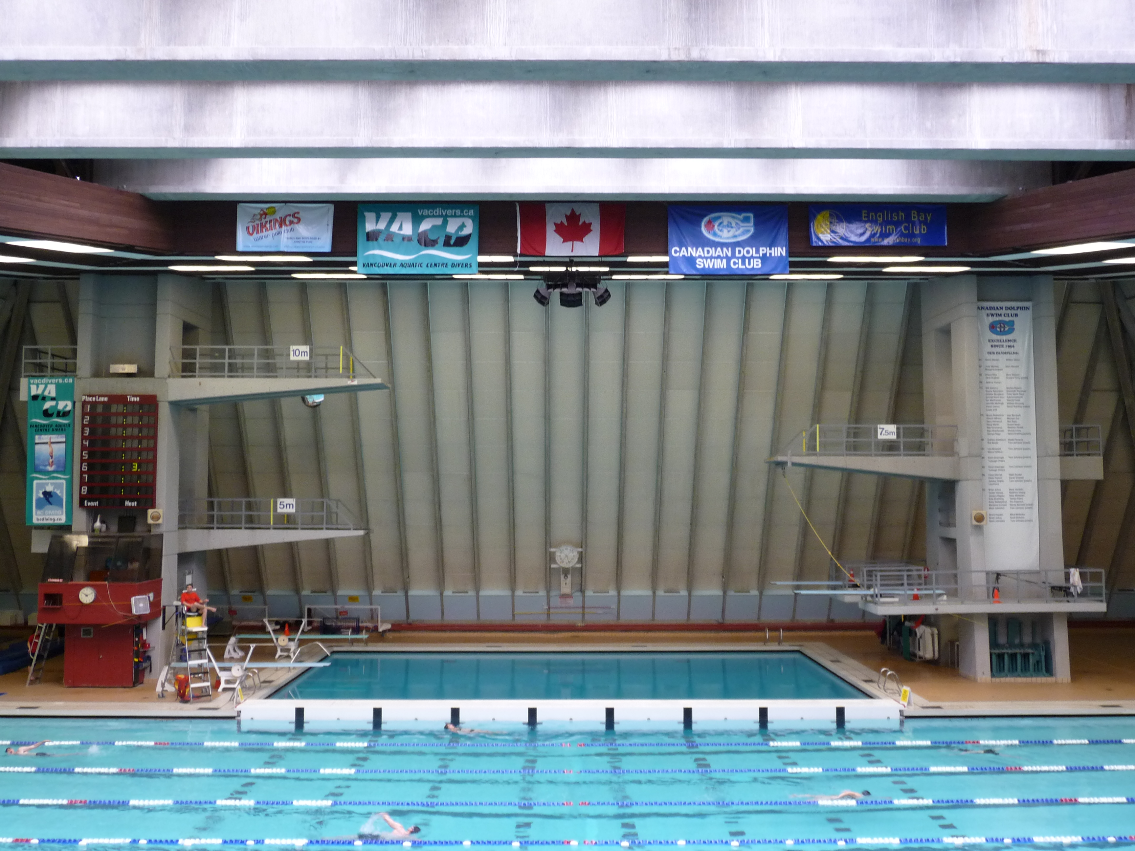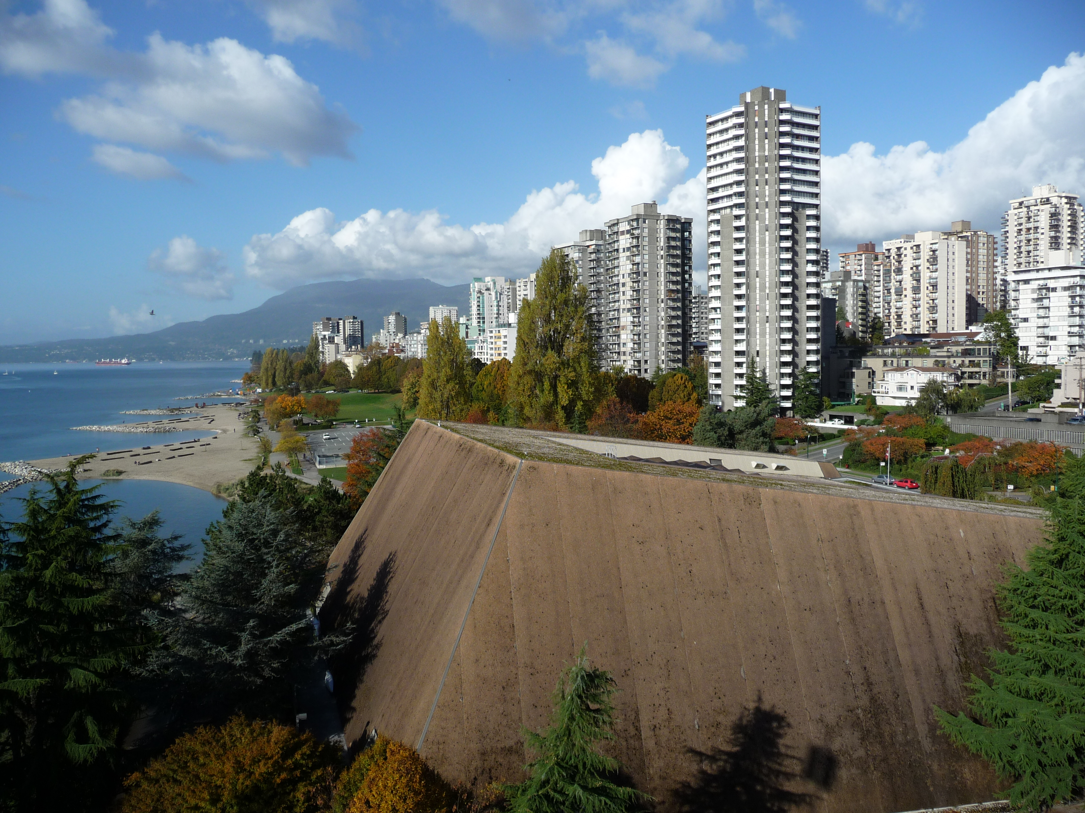
Inside of facility Outside of facility

Meet Director: Jayne McDonald

Venue: Vancouver Aquatic Centre
1050 Beach Avenue
Vancouver, BC Canada
604-665-3424

Facility: Class “A” Facility
2 X 1 meter and 2 X 3 meter springboards
5, 7, and 10 meter platforms

Rules/Eligibility: DPC (Diving Plongeon Canada) and FINA rules will apply

Entry Fees: Registration- $20 Meet Registration
Event- $15 Per Event (per team for synchro)

Awards: Medals: Gold, Silver, Bronze

Schedule: Friday, June 10:

9 am – Noon: Open Practice
Noon – End: Men’s and Women’s Platform

Saturday, June 11:

8 am – 11 am: Tier II Age Group
11 am – Noon: Open Practice
Noon – End: Men’s 1 meter
Women’s 3 meter
7 pm – 10 pm: Masters’ and Alumni Banquet

See below for more info

Sunday, June 12:

7 am – 9 am: Open Practice
9 am – Noon: Women’s 1 meter
Men’s 3 meter
Men’s and Women’s Synchro
Noon – End: Tier II Age Group

*There will be a minimum 15 minute warm-up per event and the springboard events may be run simultaneously

Dive Sheets: Dive sheets must be submitted by Dive Sheet Generator no later than 24 hours prior to the event start time

Registration: Register by email
jayne@bcdiving.ca
Deadline: May 20, 2011
Payment accepted by VISA or cheque ($US taken at par)

Host Hotels: Holiday Inn
1110 Howe St., Vancouver, BC V6Z 1R2
Phone: 1-800-663-9151
Located 4 blocks from the Aquatic Center
Offering rooms for divers at $155/night
Mention BC Diving when reserving
Click here for weblink

` Quality Inn
1335 Howe St., Vancouver, BC V6Z 1R7
Phone: 604-682-0229
Located 4 blocks from the Aquatic Center
Offering rooms for divers at $139/night
Mention BC Diving when reserving
Click here for weblink

Transportation: Getting Here:

Vancouver International Airport
20 minutes from downtown by car ($30 taxi ride)
Skytrain available direct from airport to downtown
Click here for weblink to skytrain info (see Canada Line)

Bellingham International Airport
Located in Washington State, approx 90 min by car
Quick shuttle available from airport to Vancouver
Click here for weblink to Quick Shuttle site

Staying Here:

Most attractions within the city are within walking distance from the host hotels; however, see Translink website for bus, skytrain, and sea bus info

See Tourism Vancouver for things to see and do in Vancouver

Social event: Will take place Sat night at the Holiday Inn Hotel
Ticket cost: $50
Details will be both forwarded to registered divers and posted on the BC Diving website once finalized

